**Northwest Continuum of Care**

**Question and Answer Key for NWCOC Step 2: Triage Questionnaire**

**V:02/22/2022**

This key is meant to provide the drop-down answers that are in the HMIS system and can be used as a reference. It also includes resources to assist in asking difficult questions. This does not include every question, just questions that may have quite a few possible answers.

**Question:** *Gender*

**Answers:** *Female; Male; A gender other than singularly female or male (e.g. non-binary, genderfluid, agender, culturally specific gender); Transgender; Questioning*

**Question*:*** *Gender Pronouns*

**Answers:** *(he/him/his); (she/her/hers); (they/them/theirs); (zie/hir/hirs) (no pronouns/ use the person’s name) (Other: Fill in)*

**Resources:**[*https://www.mypronouns.org/what-and-why*](https://www.mypronouns.org/what-and-why) *This article and articles on this website can assist you with asking these questions. Funders are asking these questions to learn and better serve populations who may be disproportionately experiencing homelessness. They are not asked “because HUD says so” this goes for any of the questions asked.*

**Question:** *Are you Native American? Which tribe are you an enrolled member?*

**Answers:**

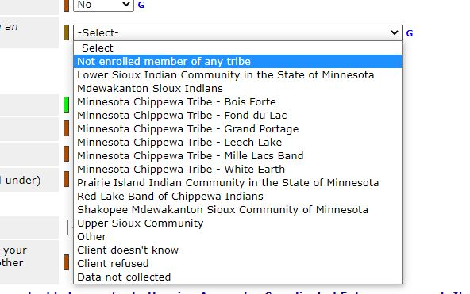

**Question:** Income Start Date

**Answers:** It is okay to just use the date of the assessment, no need to try and get the client to remember the exact date it started.

**Question: Source of Income**

**Answers:**

